Andrew Giardina

Internetworking

CMPT 307N 112

February 3, 2020

Lab 2B

**Purpose:** Witness first hand in our network topologies switches’ MAC Address tables, and the functionality differences of the tables when first initiated versus when in communication with hosts/devices.

**Q1**. The MAC Address table is empty. This is due to the fact that no devices/hosts have connected to it yet, so it hasn’t learned any MAC Addresses yet.

**Q2**. Crossover Cables are used to connect switches to other switches, or routers to other routers. Specifically, they connect two of the same devices together for communication purposes. In our lab, we connect Sw0 to Sw1 in order to physically link the two devices, and thus allow communication through the hosts (PCs) between the two switches.

**Q3**. The MAC Address table updated to include data (MAC Adds.) for PC0, PC1, and Sw1. This is because we sent a PING from PC0 to PC1, contacting the two PCs. This PING message travels from PC0 to Sw0, then to Sw1 and finally to PC1. Through this PING, all MAC Addresses were established or “learned” for Sw0’s table.

**Q4**. The MAC Address table now includes the MAC Address for PC2. This is because the PING we did from PC0 to PC2 traveled through the two switches and finally to PC2. Switch0 learned the MAC Address through this transaction.

**Q5**. The MAC Address Table now includes the MAC Address for fastEthernet 0/5 interface.

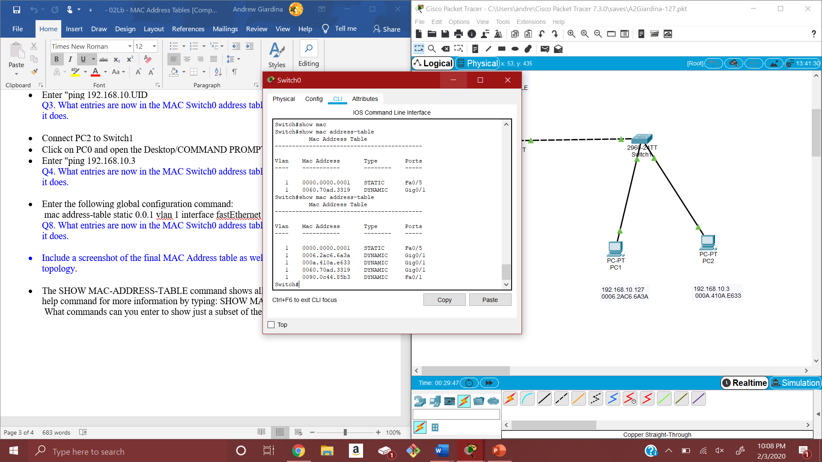**Screenshot of MAC Address Table**

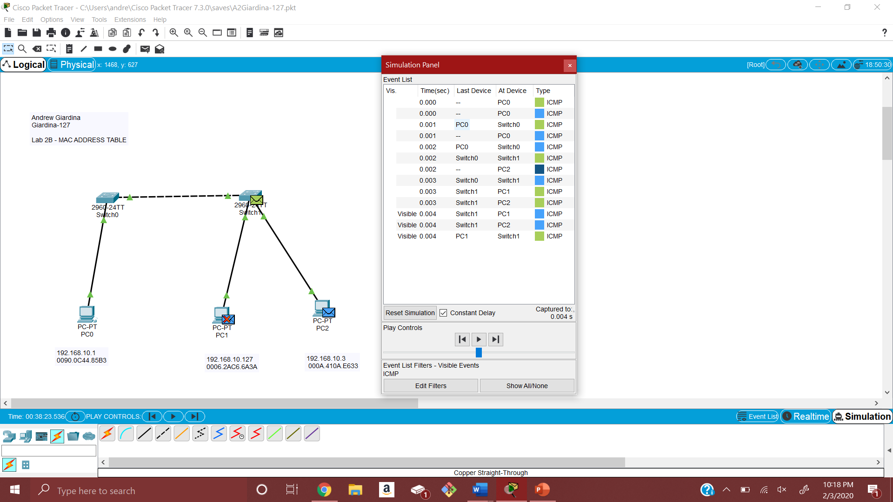**Screenshot of Final Topology + Simulation**

**New Commands:**

* Using ‘show mac-address table?’, several new commands include: dynamic, interfaces and static entry types.
* Using ‘mac address-table static ___ vlan interfact ____’ created an interface for the port specified.
* Using ‘show version’ displayed a plethora of information about the device. This includes the device’s base address.

**Reflection:**

This lab was a great simple example to show how communicating between two devices across different LANs pans out. Specifically, showing how a Switch’s MAC Address learns new addresses that it came in contact with. Little details like how PC2’s MAC address didn’t show up in Switch0’s table (because it was not pinged at the time) stressed the importance in how Switches learn MAC addresses. Its nice to see this happening rather than just learning it through lectures.

**Comments:**

I experienced a problem during the final ping of the lab (PC0 to newly connected PC2) before the simulation. The MAC Address of the PC1 disappeared from Switch0’s table, so I had to re-ping PC1 in order to get it back on the MAC table. Doing some research online, the only reason I saw for this happening was the address aging or expiring from the table after a duration of time. For my example however, this doesn’t quite make sense as there is no reason it should have expired so quickly!